VIETNAM NATIONAL UNIVERSITY OF HOCHIMINH CITY

THE INTERNATIONAL UNIVERSITY

SCHOOL OF COMPUTER SCIENCE AND ENGINEERING



**VIBRANTCOVERS**

**A CUSTOM PHONE CASE E-COMMERCE WEBSITE**

By

Hoàng Minh Khôi – ITITIU20232

APPROVED BY: ________________________________ ,

# ACKNOWLEGMENTS

It is with deep gratitude and appreciation that I acknowledge the professional guidance of Dr. Nguyen Van Sinh. His constant encouragement and support helped me to achieve my goal.

My gratitude goes to the other members of the laboratory. Their technical help and good humor made these years a great learning experience. I am grateful to the faculty of the School of Computer Science of the International University, especially Mr. Tran Trung Nghia for his support since the beginning of my studies.

Table of Contents

**ACKNOWLEGMENTS 2**

ABSTRACT 5

**CHAPTER 1 6**

**INTRODUCTION 6**

1.1. Background 6

1.2. Problem Statement 6

1.3. Scope and Objectives 6

1.4. Assumption and Solution 6

1.5. Structure of report 7

CHAPTER 2 8

LITURATURE REVIEW/RELATED WORK 8

2.1. Overview of Web Applications 8

2.1.1. E-commerce Web Applications 8

2.2. Overview of Technologies 8

2.2.1. Visual Studio Code (VS code): 8

2.2.2. Next.js: 9

2.2.3. PostgreSQL 9

2.2.4. Figma 9

**CHAPTER 3 10**

METHODOLOGY 10

3.1. Overview 10

3.2. Development Framework: Next.js 10

3.3. Database: PostgreSQL 10

3.4. Development Workflow 10

3.5. Function Requirement 11

3.6. System Design 12

3.6.1. Front-End System Design 12

3.6.2. Back-End System Design 13

3.6.3. Database Integration (PostgreSQL) 13

3.6.4. Integration and Communication 13

3.6.5. Overall System Design 13

3.7. Use Case Diagram 14

3.8. Database Design 14

3.9. Entity Relationship Diagram 14

3.10. Relational Model 14

**CHAPTER 4 14**

**IMPLEMENT AND RESULTS 14**

4.1. Implement 14

4.1.1. Front-end Architecture 14

4.1.2. Back-end Architecture 15

4.2. Results 16

4.2.1. User interface of the website 17

4.2.2. Database of the website 17

**CHAPTER 6 18**

CONCLUSION AND FUTURE WORK 18

6.1. Conclusion 18

6.2. Future work 18

**CHAPTER 7 20**

**REFERENCES 20**

# ABSTRACT

This project presents the development of a custom phone case website aimed at providing users with a unique and personalized way to protect their phones. The website is built using Next.js for both the front-end and back-end and PostgreSQL for the database. Its primary goal is to offer customers an intuitive platform for designing and ordering phone cases tailored to their individual styles and preferences.

The front end of the website, developed with Next.js, delivers a highly responsive and visually engaging user interface. The design adheres to responsive web design principles, ensuring optimal viewing across various devices. Customers can easily upload images, add text, and preview their designs before placing an order. Next.js also enables smooth page transitions and enhances the overall user experience.

On the back end, Next.js seamlessly integrates with the front end, handling API requests, order processing, and secure customer data management. It communicates efficiently with the PostgreSQL database, which stores product information, customer details, and order history. The use of PostgreSQL ensures reliable data storage, retrieval, and scalability to accommodate growing user demand.

By leveraging Next.js for both the front and back end, and PostgreSQL for the database, this website offers a cohesive and efficient platform for designing and ordering custom phone cases. The combination of these technologies enables a seamless user experience, secure transactions, and a robust foundation for future enhancements and growth.

# CHAPTER 1

# INTRODUCTION

## Background

The market for personalized consumer goods has experienced exponential growth in recent years. Individuals increasingly seek unique products that reflect their individual style and preferences. This trend is particularly evident in the mobile phone accessories market, where custom phone cases have gained immense popularity.

## Problem Statement

While numerous online platforms offer generic phone cases, there remains a gap in the market for a user-friendly e-commerce platform that specializes in high-quality, fully customizable phone cases. Existing solutions often lack intuitive design tools, limit customization options, or compromise on print quality and durability.

## Scope and Objectives

This project aims to address this gap by developing a comprehensive e-commerce platform that empowers customers to design and order custom phone cases with ease. The primary objectives are as follows:

* **Intuitive User Interface:** Develop a user-friendly website with a streamlined design process that allows customers to personalize their phone cases using their own images, artwork, or text.
* **High-Quality Customization:** Utilize advanced printing technology to ensure vibrant, high-resolution prints that are durable and resistant to fading.
* **Robust E-Commerce Functionality:** Implement secure payment processing, order management, and customer support features to ensure a seamless shopping experience.
* **Scalability and Performance:** Design the platform with scalability in mind to accommodate future growth and maintain optimal performance under varying traffic loads.

## Assumption and Solution

Given the growing demand for personalized products and the increasing prevalence of mobile phone usage, it is assumed that a significant market exists for a dedicated e-commerce platform specializing in high-quality, customizable phone cases. This project proposes to address this demand by developing a platform that leverages Next.js, Java Spring Boot, for a seamless user experience and MySQL for robust data management. The combination of these technologies will enable the creation of a user-friendly, scalable, and secure e-commerce solution that caters to the specific needs of the target market.

## Structure of report

The thesis will be structured as follows:

* **Chapter 2: Literature Review** - This chapter will delve into existing research and literature on e-commerce trends, customization technologies, and the specific applications of Next.js and PostgreSQL in e-commerce development.
* **Chapter 3: Methodology** - This chapter will outline the systematic approach taken to develop the platform, including requirement gathering, database design, system architecture, and implementation strategies.
* **Chapter 4: Implementation and Results** - This chapter will provide a detailed account of the development process, showcasing the implemented features, the front-end and back-end functionalities, and the results achieved in terms of platform performance and user experience.
* **Chapter 5: Discussion and Evaluation** - This chapter will critically evaluate the platform's success in meeting its objectives. It will analyze user feedback, compare the platform with existing solutions, and assess its strengths and weaknesses.
* **Chapter 6: Conclusion and Future Work** - This final chapter will summarize the project's findings and contributions, emphasizing the platform's potential impact on the custom phone case market. It will also propose avenues for future research and development to further enhance the platform's capabilities and address emerging market trends.

# CHAPTER 2

# LITURATURE REVIEW/RELATED WORK

## Overview of Web Applications

Web applications have become integral to modern life, transforming how we interact with information, services, and each other online. Unlike traditional desktop applications, web apps operate within a web browser, eliminating the need for complex installations and ensuring accessibility across various devices. These applications offer a range of functionalities, from simple utilities to complex enterprise-level systems, and their popularity continues to rise due to their convenience, cross-platform compatibility, and ease of deployment.

### E-commerce Web Applications

Within the broader landscape of web apps, e-commerce platforms have revolutionized the retail industry. These platforms enable businesses to showcase products, process transactions, and manage customer relationships online. A successful e-commerce web app requires a well-designed user interface (UI), a robust backend infrastructure, and secure data management. The ability to personalize the shopping experience is increasingly crucial, as customers seek unique products and tailored recommendations.

## Overview of Technologies

This section explores the fundamental technologies, frameworks, and tools employed to create robust and interactive web applications. The review covers both frontend and backend technologies, discussing their roles, advantages, and best practices in the context of web application development.

### Visual Studio Code (VS code):

A lightweight and versatile code editor widely used in web development. The review explores the features and capabilities of VS Code, highlighting its popularity among developers due to its extensibility, powerful editing and debugging tools, and support for a wide range of programming languages and frameworks. The review also discusses notable extensions and plugins available for VS Code that enhance the development experience, making it a preferred choice for many developers.

### Next.js:

An in-depth examination of the Next.js framework, discussing its features, benefits, and use cases in web application development. It also discusses the advantages of using Next.js in terms of scalability, maintainability, and code reusability. Notable examples of successful applications built with Next.js are also highlighted.

### Spring Boot:

A comprehensive review of Spring Boot 3.2.0, a Java-based framework for building enterprise-

grade backend applications. The review examines Spring Boot's architecture, dependency

injection, and RESTful API development capabilities.

### MySQL

This relational database management system offers robustness, scalability, and security for storing product data, customer information, and order details. Its flexibility and ACID compliance make it a reliable choice for e-commerce applications.

### Figma

A powerful design tool used for creating user interfaces and user experiences. The review examines the features and capabilities of Figma, including its collaborative design environment, vector editing, prototyping, and design systems. It discusses how Figma enhances the design process by allowing multiple designers to work simultaneously and providing a seamless transition from design to development.

# CHAPTER 3

# METHODOLOGY

## Overview

This chapter outlines the methodological approach adopted for the development of the custom phone case e-commerce platform. The project leverages a modern technology stack to ensure a robust, scalable, and user-friendly solution.

## Development Framework: Next.js – Spring Boot

Next.js, a React-based framework, is chosen as the foundation for both front-end and back-end development. This full-stack approach streamlines the development process, enhances performance, and promotes code reusability.

* **Front-End Development:** Next.js empowers the creation of a visually appealing and interactive user interface. Its server-side rendering capabilities and automatic code splitting optimize page load times and enhance the overall user experience.
* **Back-End Development:** Spring Boot (Java) handles backend operations. It exposes a RESTful API that the Next.js frontend consumes via HTTP requests. This separation allows the frontend and backend to scale independently and use the best tools for each layer. The frontend communicates with the Spring Boot API through a centralized API client, enabling seamless data fetching, order processing, and other backend operations.

## Database: MySQL

MySQL, a powerful and reliable relational database management system, is selected to store and manage product information, customer data, order details, and design assets. MySQL's robust features, such as ACID compliance, data integrity checks, and advanced indexing, ensure data accuracy and security.

## Development Workflow

The development workflow is iterative and agile, incorporating continuous testing and feedback to ensure the platform meets user needs and expectations. The development process is divided into the following stages:

* **Requirement Gathering:** Comprehensive user research and competitor analysis are conducted to identify key features, functionalities, and design preferences.
* **Database Design:** A detailed database schema is created to model product categories, attributes, customer information, order history, and other relevant data.
* **Front-End Development:** The user interface is designed and implemented using Next.js components, focusing on intuitive navigation, responsive design, and visually appealing aesthetics.
* **Back-End Development:** Backend operations are handled by Spring Boot (Java), which exposes REST API endpoints. The Next.js frontend communicates with these endpoints via HTTP requests. Spring Boot uses Spring Data JPA to interact with the MySQL database, handling data fetching, order processing, and other backend operations. This separation allows the frontend and backend to scale independently and use the best tools for each layer.
* **Integration and Testing:** The front-end and back-end components are integrated, and comprehensive testing is conducted to ensure functionality, performance, and security.

By adhering to this structured methodology and leveraging the strengths of Next.js, Spring Boot and MySQL, this project aims to deliver a custom phone case e-commerce platform that exceeds customer expectations and establishes a competitive edge in the market.

## Function Requirement

The following functional requirements outline the core functionalities the e-commerce platform must fulfill:

**User Authentication and Authorization**

* **Login:** The system shall enable registered users to log in securely using their email address and password, authenticated through Kinde.com.
* **Error Handling:** The system shall display clear error messages for invalid login credentials.
* **Account Management:** Registered users shall have the ability to view and update their profile information, including shipping addresses and payment methods.

**Case Customization**

* **Image Upload and Management:**
  + The system shall allow users to upload images using UploadThing.com for case customization.
  + Images shall be stored securely and efficiently in PostgreSQL.
  + The system shall provide image editing tools (e.g., cropping, resizing) for users to optimize their uploaded images.
* **Design Customization:**
  + The system shall offer a variety of customization options, including text input, font selection, color choices, and layout adjustments.
  + Users shall have the ability to preview their customized designs in real time before placing an order.
  + Image configuration and manipulation shall be implemented using DOM manipulation and hooks for a dynamic user experience.

**Order Placement and Payment**

* **Payment Processing:** The system shall integrate with Stripe to securely process online payments.
* **Order Confirmation:** The system shall generate order confirmation emails with order details and estimated delivery times.
* **Post-Purchase Communication:** The system shall utilize Resend.com to send follow-up emails regarding order status and shipping updates.

**Additional Features**

* **Product Catalog:** The system shall display a comprehensive product catalog with clear images, descriptions, and pricing information.
* **Customer Support:** The system shall provide channels for customer support, such as a contact form or live chat.

By incorporating these functional requirements, the e-commerce platform will provide a user-friendly and feature-rich experience for customers to design and order their unique, personalized phone cases.

## System Design

The system design for the custom phone case e-commerce platform comprises both front-end and back-end components, seamlessly integrated to ensure efficient data flow and optimal user experience.

### 3.6.1. Front-End System Design

The front-end architecture, built using Next.js, focuses on creating an intuitive and visually engaging user interface. Key considerations include:

* **Layout and Navigation:** A clear and concise layout with intuitive navigation paths will guide users through the customization and purchasing process.
* **Customization Interface:** A user-friendly drag-and-drop interface will allow customers to upload images, add text, choose colors, and preview their designs in real-time.
* **Responsive Design:** The interface will be optimized for various screen sizes and devices, ensuring a seamless experience on desktops, tablets, and mobile phones.
* **Performance Optimization:** Techniques such as code splitting and lazy loading will be employed to minimize initial page load times and improve overall performance.

### 3.6.2. Back-End System Design

The back-end system, also developed using Next.js API routes, handles the business logic, data processing, and communication with the database. Key considerations include:

* **API Endpoints:** RESTful API endpoints will be designed to handle product information retrieval, design customization data, order placement, and user authentication.
* **Data Validation and Security:** Robust input validation and security measures will be implemented to protect against vulnerabilities and unauthorized access.
* **Order Management:** A comprehensive order management system will track order status, process payments, and manage customer communication.

### 3.6.3. Database Integration (MySQL)

MySQL will be utilized as the database for storing and managing product data, customer information, order details, and design assets. The database schema will be designed to ensure data integrity, consistency, and efficient retrieval.

### 3.6.4. Integration and Communication

The Next.js front-end will communicate with the Spring-Boot back-end through API calls. Data will be exchanged in JSON format, ensuring standardized and efficient communication between the client and server.

### 3.6.5. Overall System Design

The overall system design aims to create a cohesive and scalable e-commerce platform that delivers a seamless user experience. By integrating Next.js for front-end and Spring-Boot for back-end development and utilizing MySQL for reliable data management, the platform will be optimized for performance, security, and future growth.

## Use Case Diagram

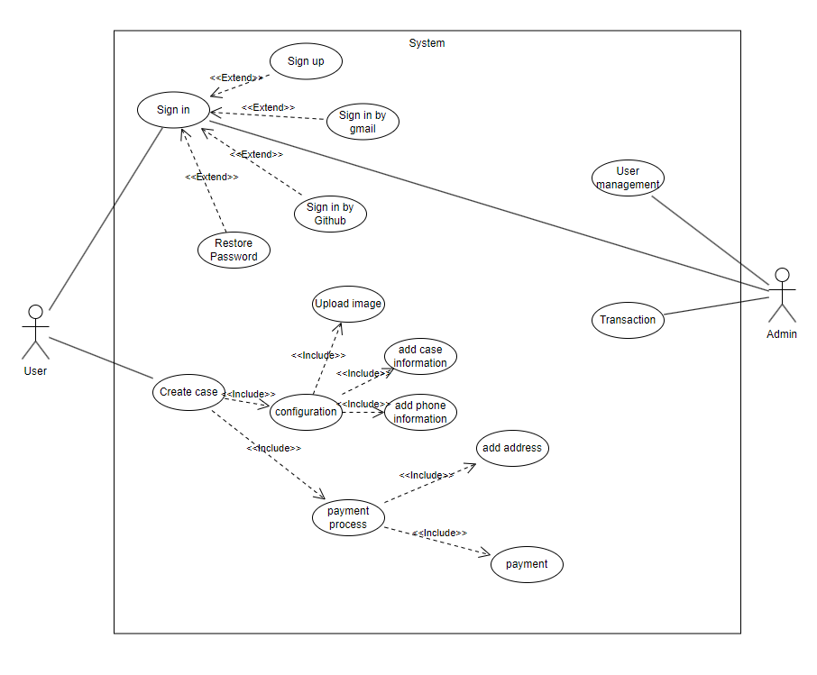

## Database Design

The database design for the e-commerce platform is modeled using a relational database approach, leveraging MySQL as the database management system. The schema is structured to ensure data integrity, efficient retrieval, and scalability to accommodate future growth.

Entities and Relationships

The database consists of the following entities, along with their attributes and relationships:

1. User

* Attributes:
  + id (Primary Key)
  + email (Unique)
  + password (Hashed)
  + createdAt
  + updatedAt
* Relationships:
  + One-to-many relationship with Order (A user can place multiple orders)

2. PhoneModel

* Attributes:
  + id (Primary Key)
  + name (Unique)
* Relationships:
  + One-to-many relationship with Configuration (A phone model can be associated with multiple configurations)

3. CaseMaterial

* Attributes:
  + id (Primary Key)
  + name (Unique)
* Relationships:
  + One-to-many relationship with Configuration (A case material can be used in multiple configurations)

4. CaseFinish

* Attributes:
  + id (Primary Key)
  + name (Unique)
* Relationships:
  + One-to-many relationship with Configuration (A case finish can be applied to multiple configurations)

5. CaseColor

* Attributes:
  + id (Primary Key)
  + name (Unique)
* Relationships:
  + One-to-many relationship with Configuration (A case color can be used in multiple configurations)

6. Configuration

* Attributes:
  + id (Primary Key)
  + width
  + height
  + imageUrl
  + colorId (Foreign Key referencing CaseColor)
  + modelId (Foreign Key referencing PhoneModel)
  + materialId (Foreign Key referencing CaseMaterial)
  + finishId (Foreign Key referencing CaseFinish)
  + croppedImageUrl (Optional)
* Relationships:
  + One-to-many relationship with Order (A configuration can be associated with multiple orders)

7. Order

* Attributes:
  + id (Primary Key)
  + configurationId (Foreign Key referencing Configuration)
  + userId (Foreign Key referencing User)
  + amount
  + isPaid
  + statusId (Foreign Key referencing OrderStatus)
  + shippingAddressId (Foreign Key referencing ShippingAddress)
  + billingAddressId (Foreign Key referencing BillingAddress)
  + createdAt
  + updatedAt

8. OrderStatus

* Attributes:
  + id (Primary Key)
  + name (Unique)

9. ShippingAddress

* Attributes:
  + id (Primary Key)
  + name
  + street
  + city
  + postalCode
  + country
  + state (Optional)
  + phoneNumber (Optional)

10. BillingAddress

* Attributes:
  + id (Primary Key)
  + name
  + street
  + city
  + postalCode
  + country
  + state (Optional)
  + phoneNumber (Optional)

## Entity Relationship Diagram

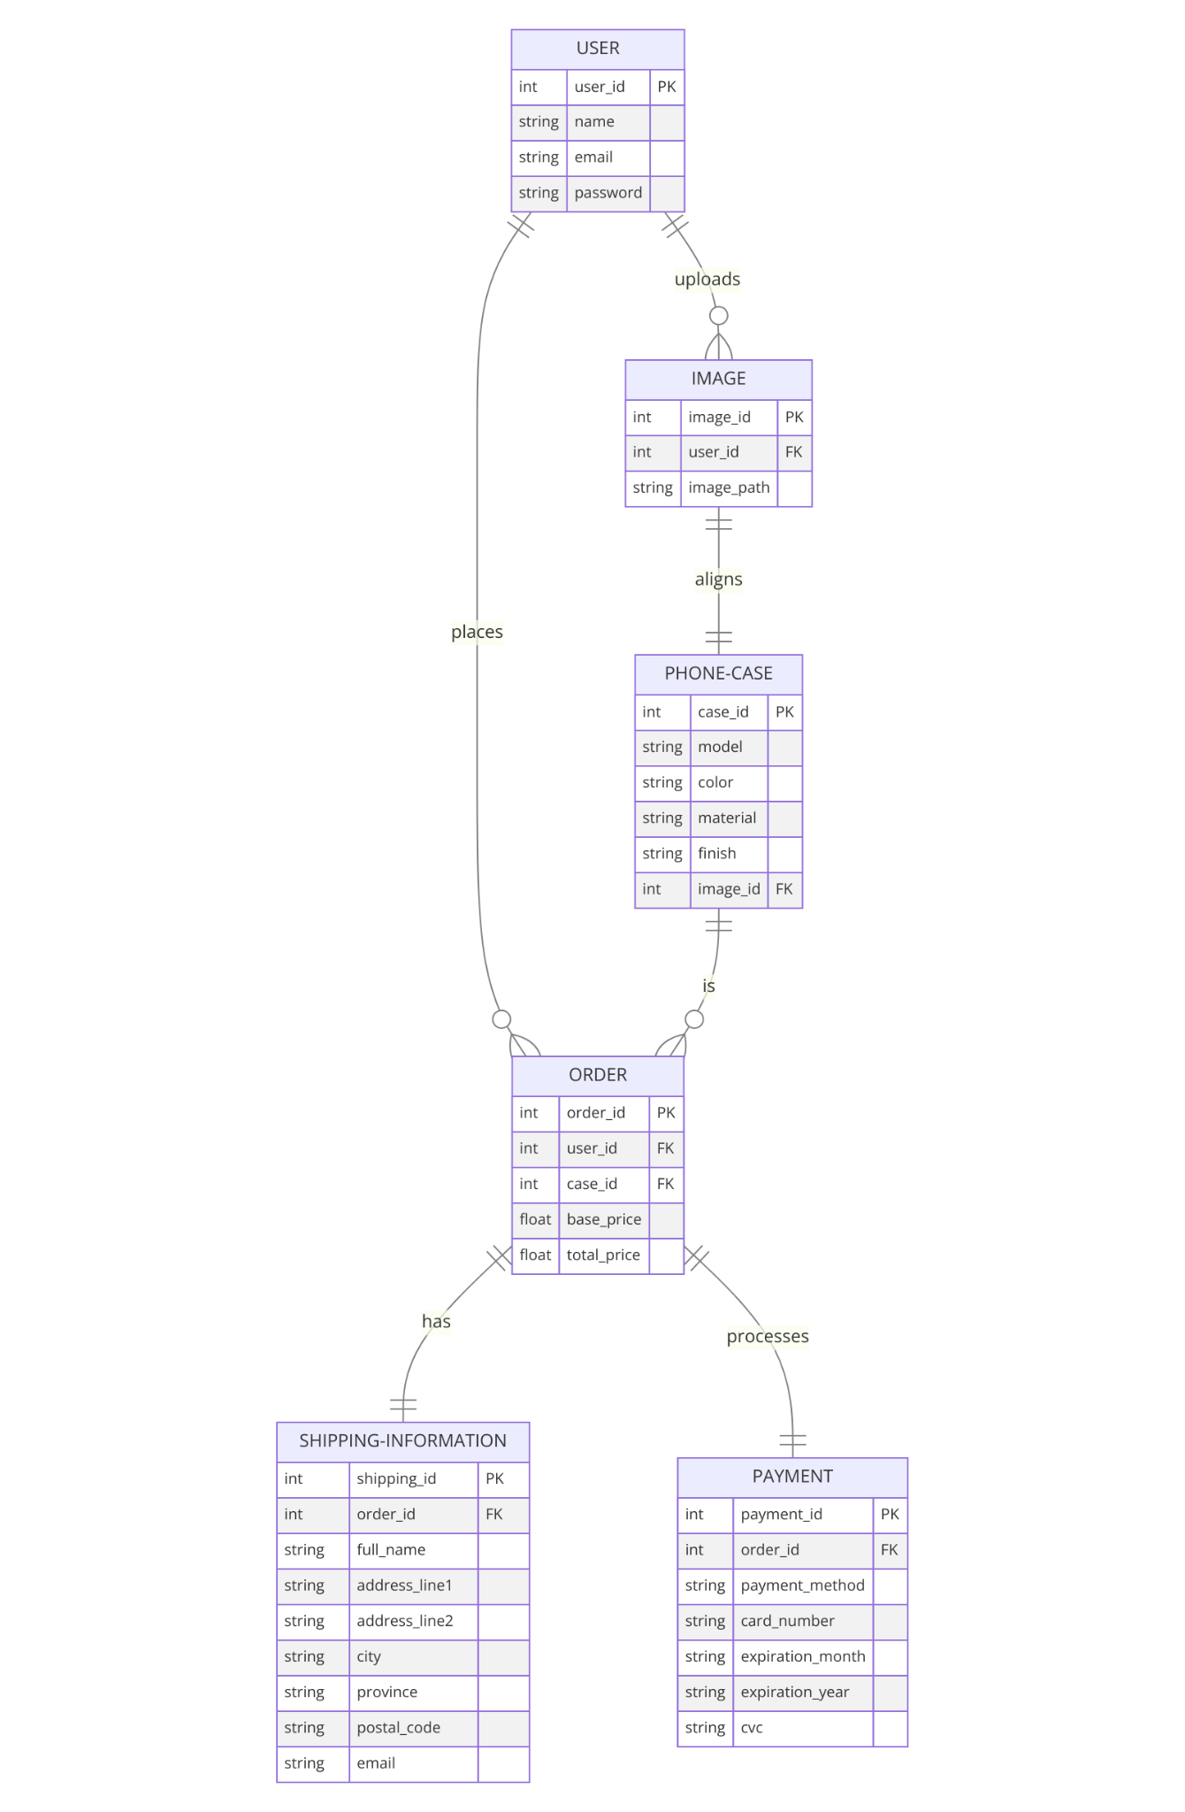

## Sequence Diagram

# 

# CHAPTER 4

# IMPLEMENT AND RESULTS

## Implement

### Front-end Architecture

The front-end architecture of the e-commerce platform follows a component-based structure using Next.js, enhanced with Tailwind CSS for styling and ShadcnUI for pre-built React components. This approach fosters modularity, reusability, and a streamlined development process.

* **Component-Based Structure:** The UI is composed of reusable components, each responsible for rendering a specific part of the interface (e.g., product card, navigation bar, image uploader). This modularity simplifies development and maintenance, as changes to a component are isolated and do not affect the rest of the application.
* **Next.js Pages and Components:** Next.js pages provide a structured way to organize components and their associated logic. Components can be nested within pages, promoting a hierarchical structure and clear separation of concerns.
* **Styling with Tailwind CSS:** Tailwind CSS, a utility-first CSS framework, offers a flexible and efficient way to style components. Its utility classes provide a comprehensive set of pre-defined styles that can be composed to create any desired look, eliminating the need to write custom CSS from scratch.
* **ShadcnUI:** ShadcnUI is a library of pre-built React components that integrate seamlessly with Tailwind CSS. These components offer a head start in development, providing customizable building blocks for common UI elements such as buttons, forms, and navigation menus.
* **Data Fetching:** Next.js's data fetching mechanisms are utilized to fetch product data, user information, and other dynamic content. A state management library (Redux) can be employed to manage the application's state in a centralized and predictable way.

**Key Advantages of this Front-End Architecture:**

* **Rapid Development:** Tailwind CSS and ShadcnUI accelerate development by providing pre-built styles and components, reducing the need to write boilerplate code.
* **Consistent Design:** The use of Tailwind CSS enforces a consistent design language throughout the application, ensuring a cohesive user experience.
* **Performance Optimization:** Next.js features such as code splitting and server-side rendering optimize page load times and overall performance.
* **Maintainability and Scalability:** The component-based approach promotes code reusability and maintainability, making it easier to add new features or modify existing ones. The architecture is also scalable, accommodating future growth and increased complexity.
* **Developer Experience:** The combination of Next.js, Tailwind CSS, and ShadcnUI provides a streamlined development experience, empowering developers to focus on building features rather than writing repetitive styling and UI code.

### Back-end Architecture

The back-end architecture of the e-commerce website follows the Layered Architecture pattern. It consists of four layers, each responsible for specific functionalities and data processing:

1. **Controller Layer:** The controller layer handles HTTP request management and acts as the entry point for incoming requests from the client. It receives the requests, processes them, and interacts with the appropriate service layer to retrieve or update data. The controller layer is responsible for validating inputs, handling authentication and authorization, and returning the appropriate HTTP responses.
2. **Service Layer**: The service layer handles the business logic of the application. It encapsulates the logic for various operations and functionalities required by the web application. The service layer interacts with the repository layer to fetch or store data, and it processes and manipulates the data, as necessary. It ensures that the business logic is separated from the presentation layer and can be reused across different controllers.
3. **Repository Layer:** The repository layer is responsible for storing and accessing data. It interacts with the underlying database, in this case, Supabase, to perform basic query functions such as creating, reading, updating, and deleting data (CRUD operations). The repository layer abstracts the database operations, providing a simplified and consistent interface for the service layer.
4. **Model Layer:** The model layer represents the database architecture and defines the structure of the data. It consists of entities or classes that map to database tables. The model layer provides a clear representation of the data schema and defines relationships between entities. It ensures data consistency and integrity.

**Data Processing Flow:** In the data processing flow, when a client sends a request, it is received by the controller layer. The controller layer validates the request, performs any necessary authentication or authorization checks, and then forwards the request to the appropriate service layer method. The service layer, which encapsulates the business logic, processes the request, accessing data from the repository layer as needed. The repository layer interacts with the database, using the model layer to retrieve or store data. The processed data is then returned to the service layer, which in turn returns the response back to the client through the controller layer.

This layered architecture provides separation of concerns, modularity, and scalability, making it easier to maintain and extend the streaming music site in the future. The clear separation of responsibilities between layers enables better code organization and promotes code reusability.

## Results

Github Links: <https://github.com/khm2502/vibrantcovers>

Figma: <https://www.figma.com/proto/8ITSy1bbOZOEEIz5mkv8cq/Webapp_project?node-id=0-1&t=ii0ZpMPqwjJL2ICV-1>

### User interface of the website

Figma:

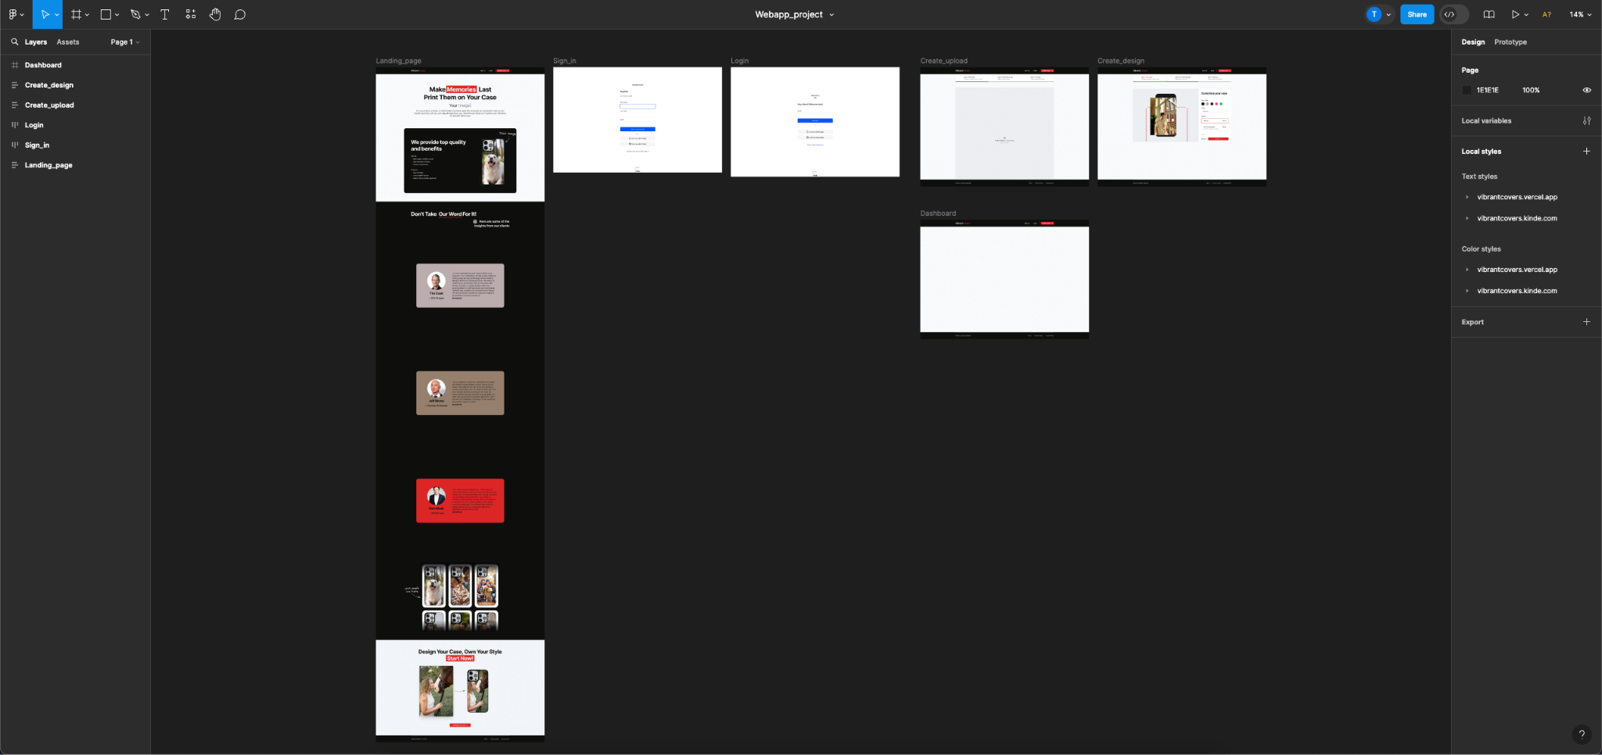

Signup and Signin page:

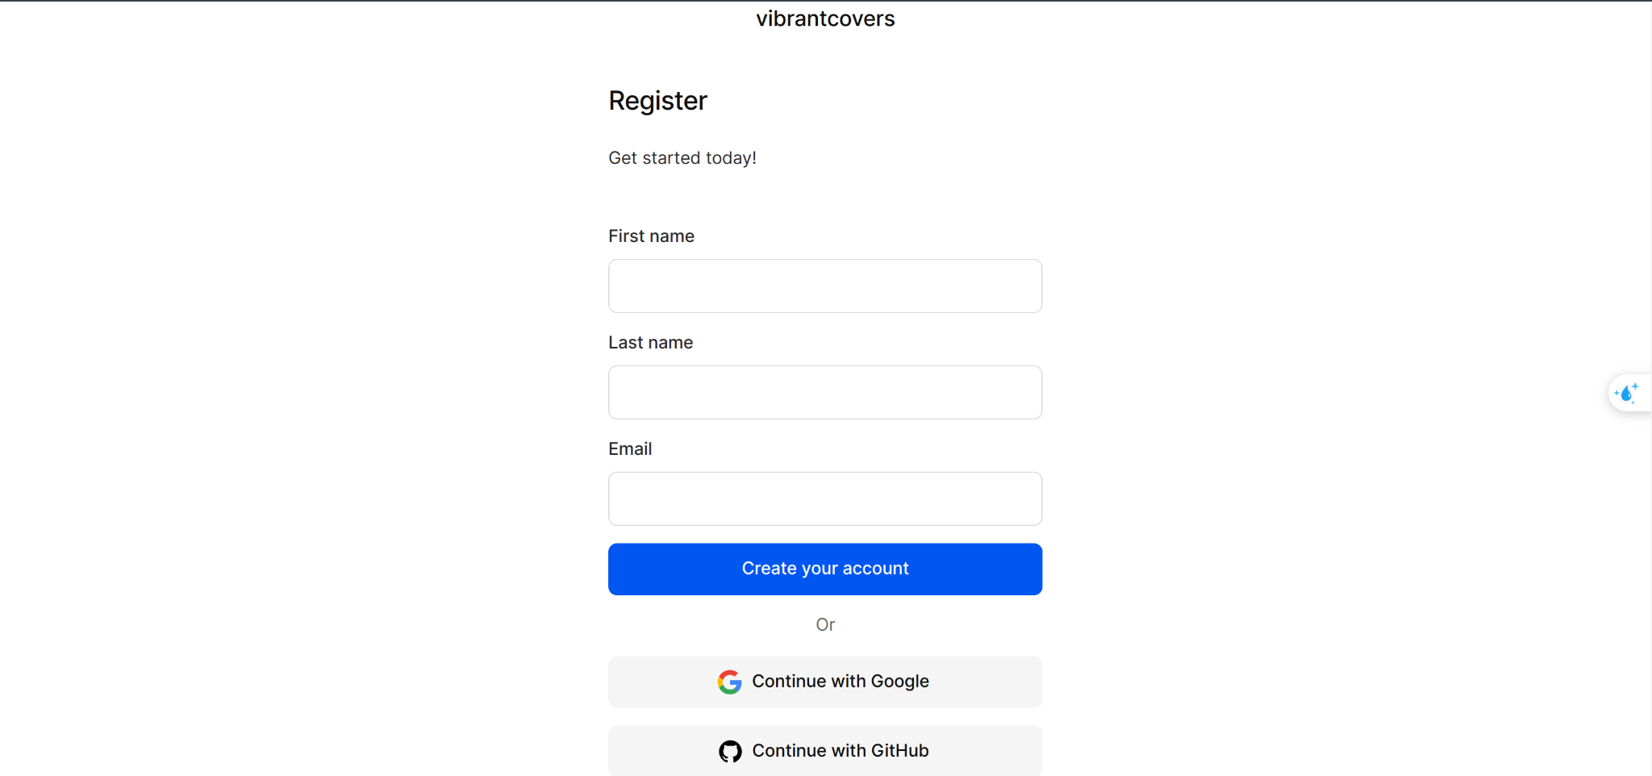

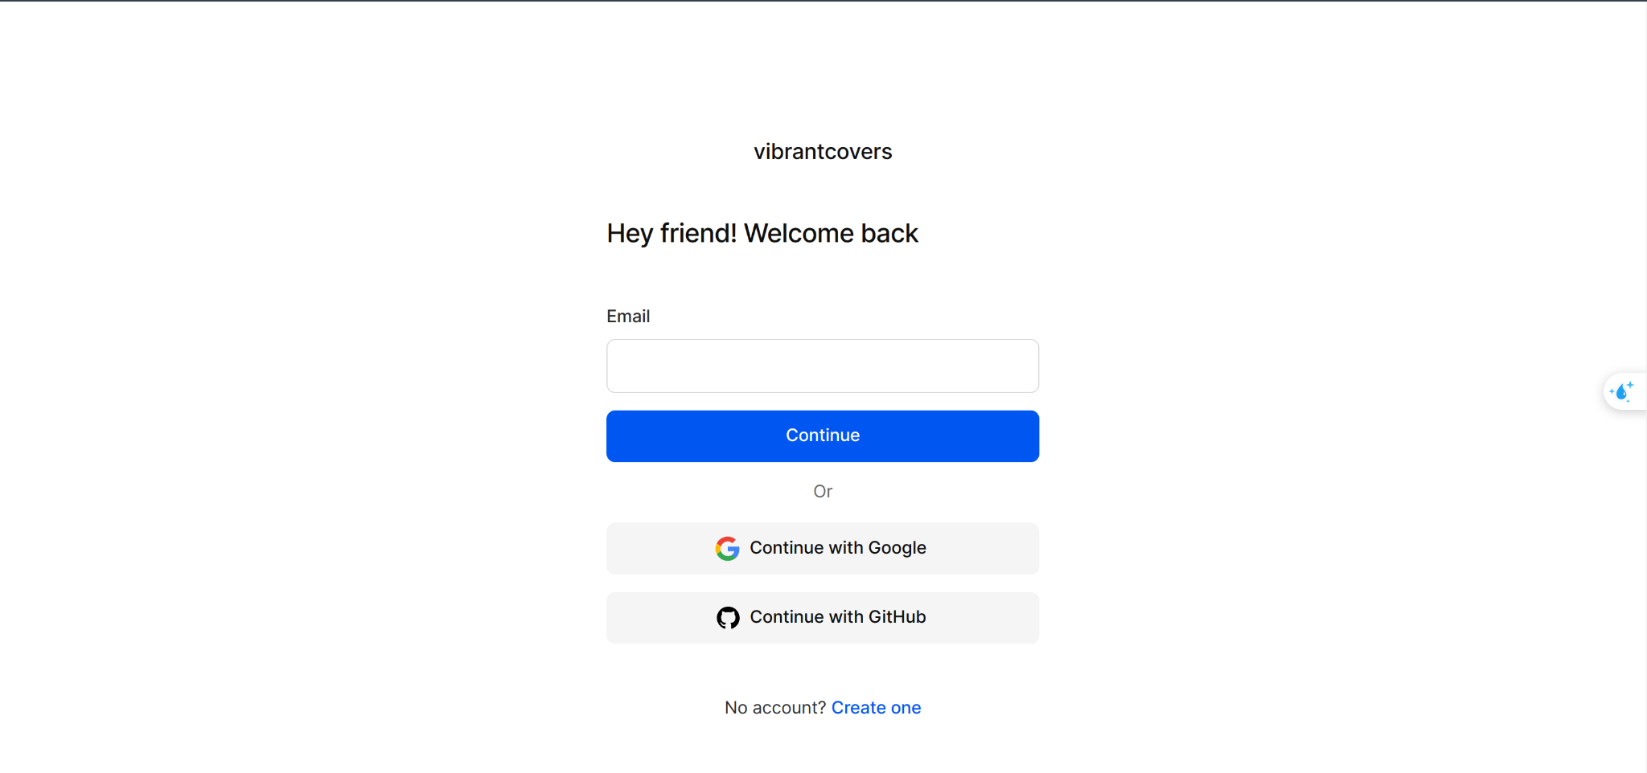

Homepage:

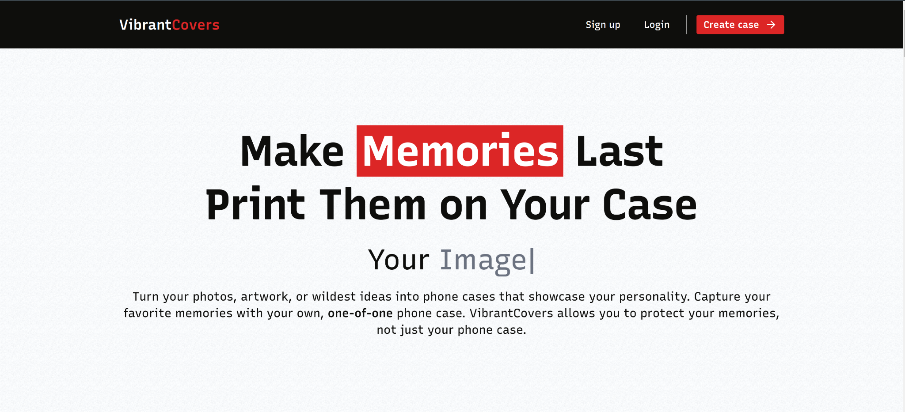

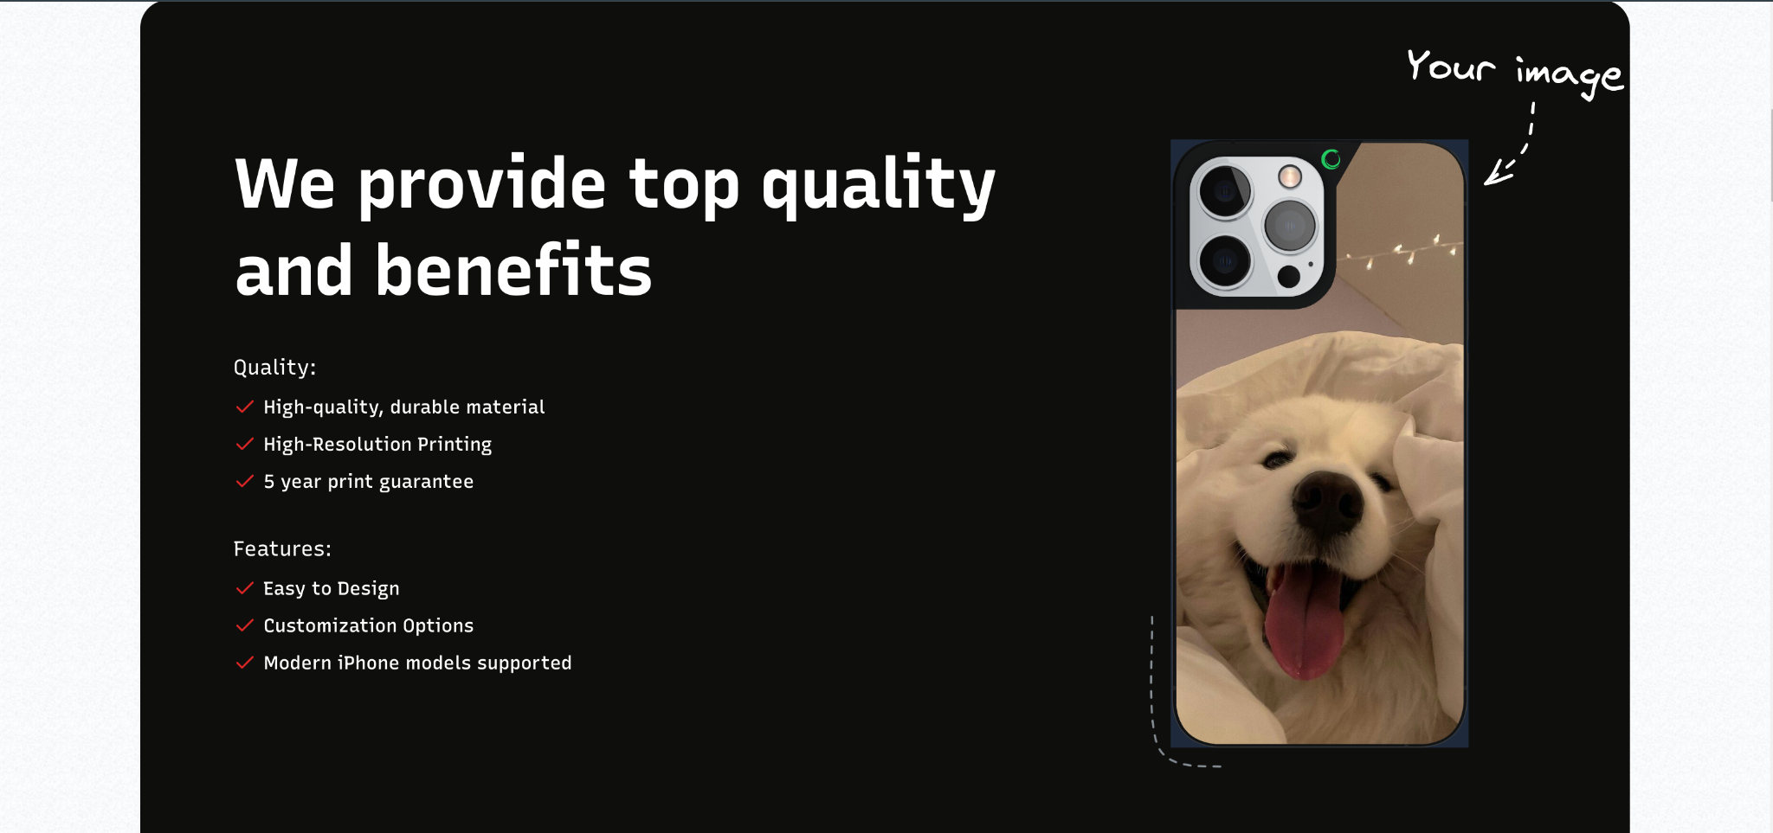

Upload page:

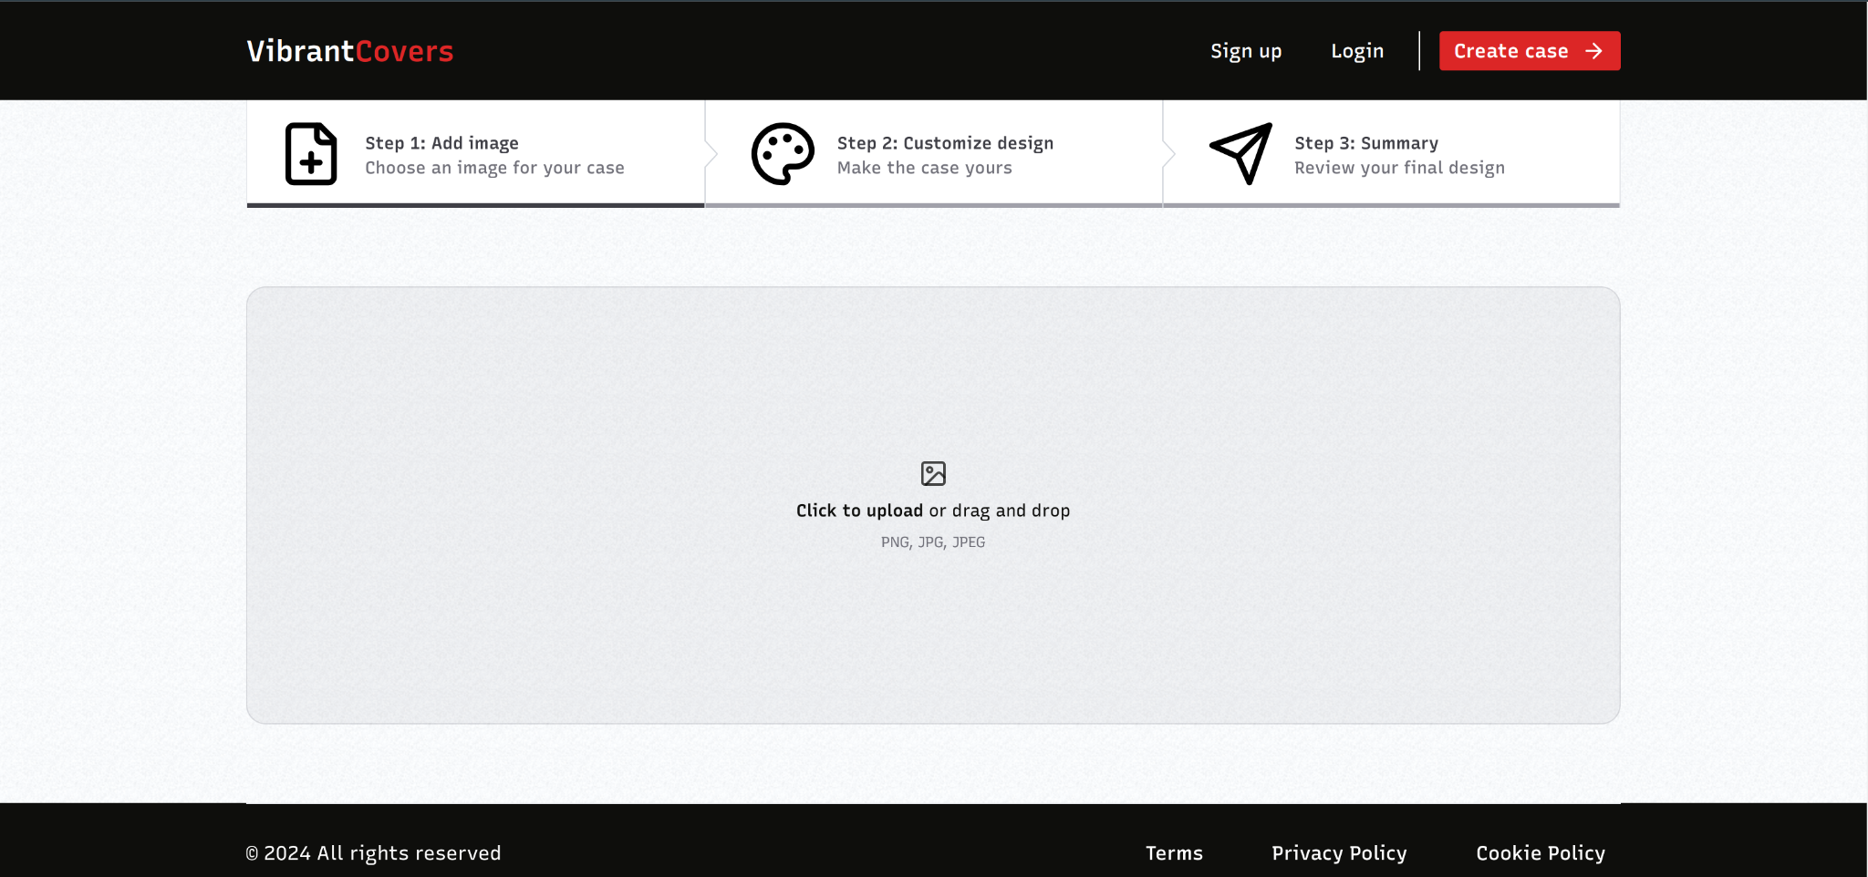

Configuration page:



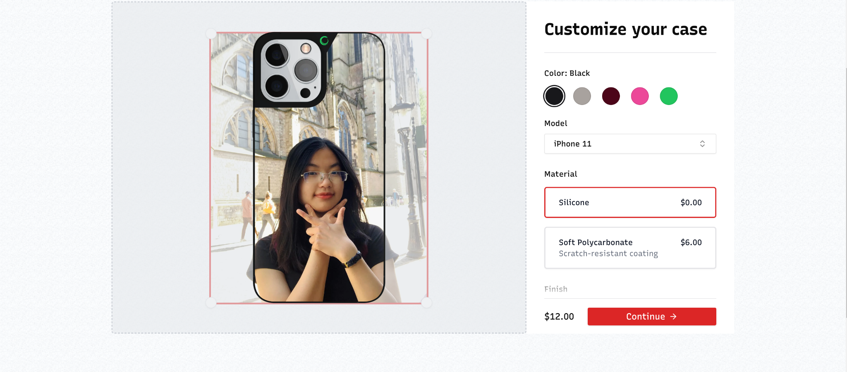

Preview page:

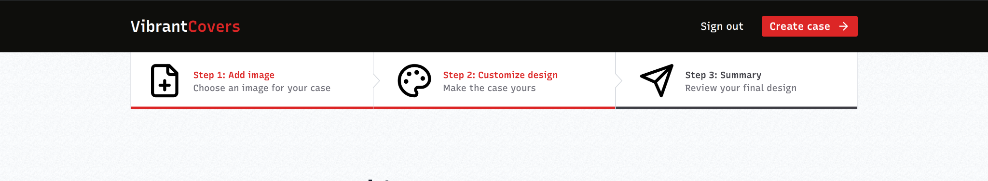

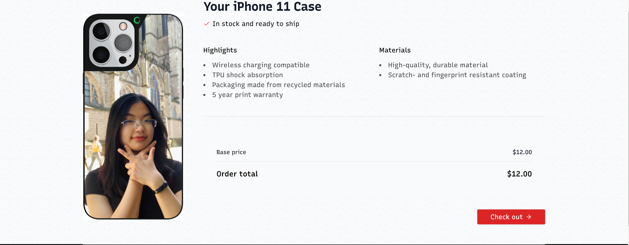

Payment page:

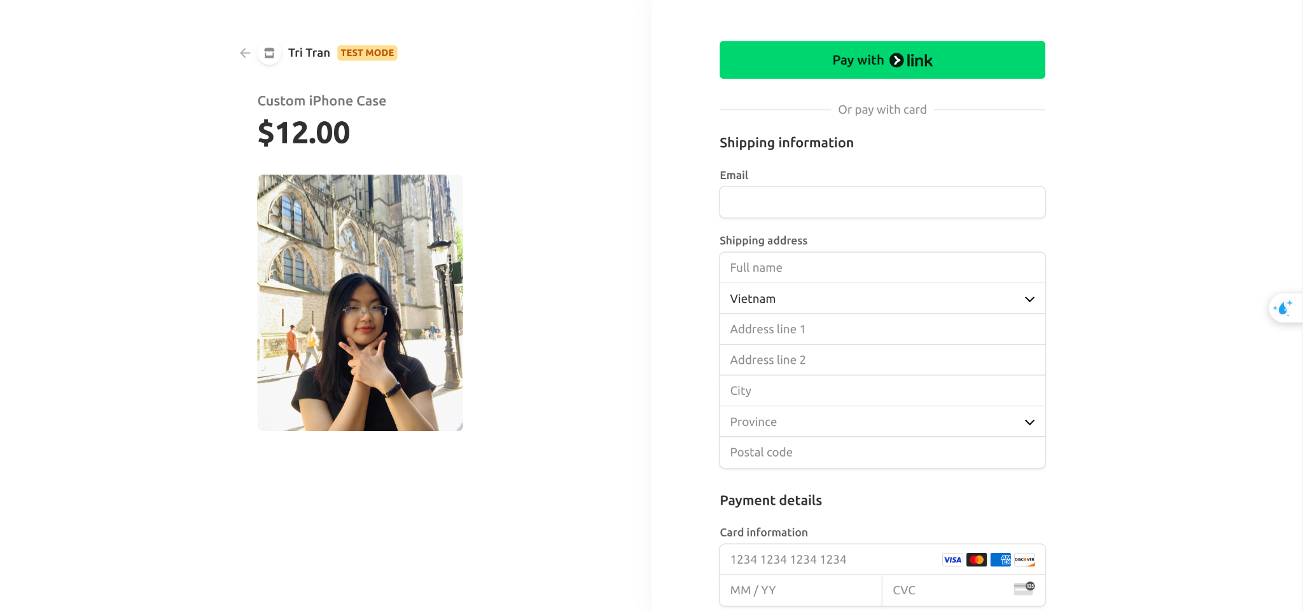

Thank you page:

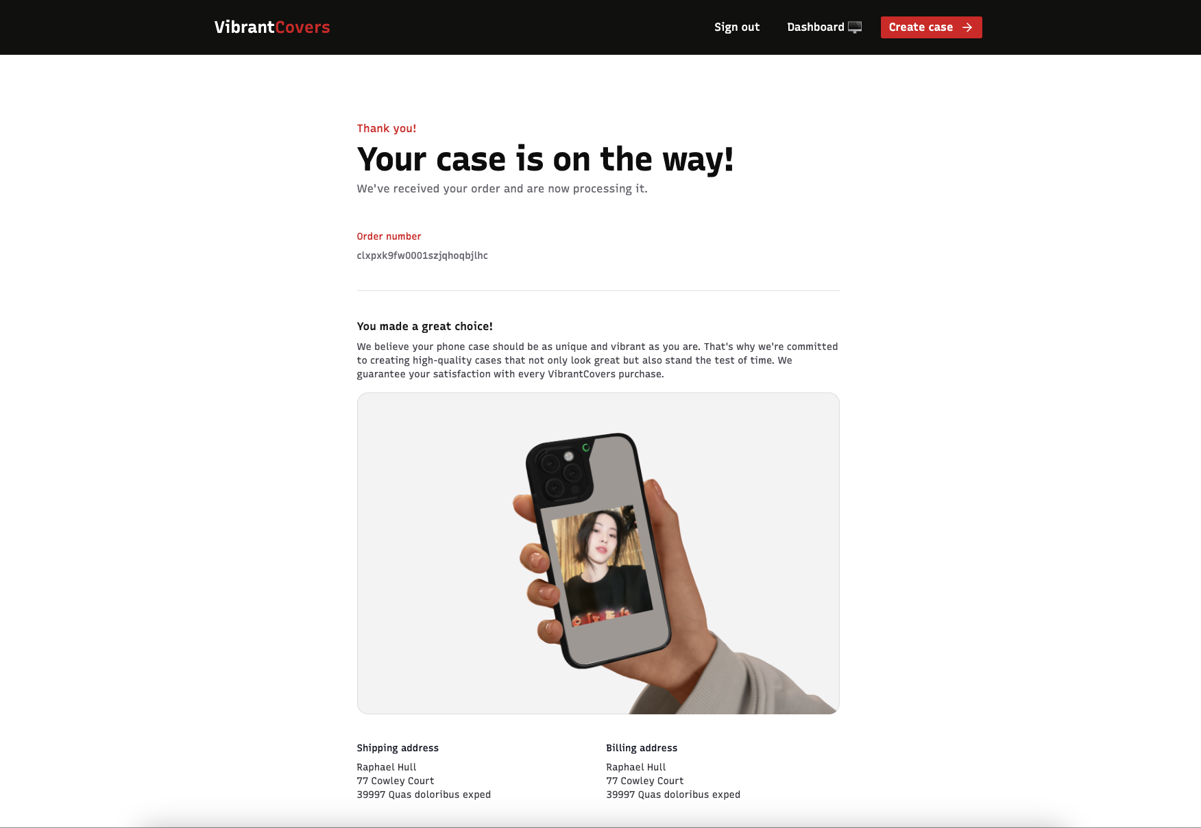

Email page:

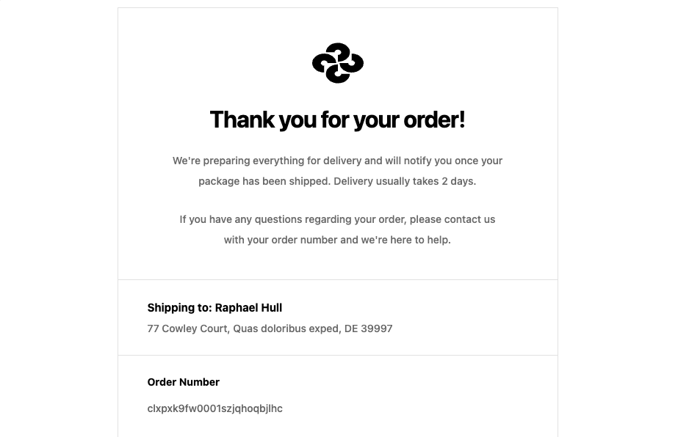

### Database of the website

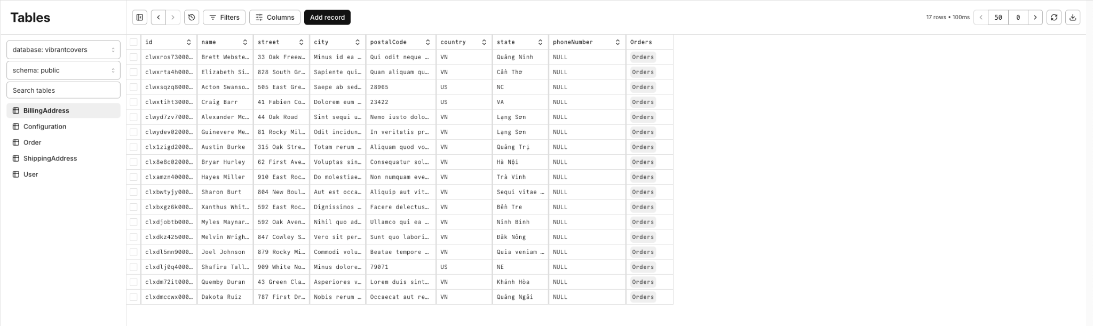

# CHAPTER 6

# CONCLUSION AND FUTURE WORK

## Conclusion

In conclusion, this report details the development of a custom phone case e-commerce platform. The platform uses Next.js for frontend development, Spring Boot (Java) for backend development, MySQL for data management, and integrates third-party services including Stripe (payments), UploadThing (image management), and Resend (email). These technologies and services deliver a user-friendly and efficient platform for personalized phone cases.

The project met its objectives by providing an intuitive and visually appealing user interface, supported by Tailwind CSS and Shadcn UI. The platform enables customers to upload and customize images, design phone cases, and place orders securely. MySQL provides reliable data storage and retrieval, while external services streamline e-commerce processes.

The results show the effectiveness of using Next.js for the frontend, Spring Boot for the backend, MySQL for data management, and specialized services for specific functionalities in e-commerce development. This combination delivers a seamless user experience, efficient order processing, and a solid foundation for future enhancements.

## Future work

While the developed platform provides a solid foundation, several potential avenues for future work and expansion exist:

* **Enhanced Customization:** Implement advanced customization features such as 3D previews, augmented reality (AR) integration, and the ability to create designs for additional phone models and accessories.
* **Social Sharing:** Integrate social media sharing functionalities to allow customers to showcase their designs and potentially attract new customers.
* **Loyalty Programs and Discounts:** Develop customer loyalty programs and implement promotional strategies to encourage repeat business and customer retention.
* **Data Analytics:** Integrate analytics tools to gather insights into customer behavior, product preferences, and sales trends, facilitating data-driven decision-making for further improvements.
* **Mobile App:** Develop a mobile app version of the platform to offer customers a convenient way to create and order custom phone cases on their smartphones.

By continuously innovating and expanding the platform's capabilities, VibrantCovers can solidify its position in the competitive market of personalized phone cases and cater to the evolving needs and preferences of customers.

# CHAPTER 7

# REFERENCES

1. *Docs*. (n.d.). Next.js. <https://nextjs.org/docs>
2. *uploadthing*. (n.d.). Uploadthing. <https://uploadthing.com/>
3. *Login · Resend*. (n.d.). <https://resend.com/emails>
4. *Welcome*. (n.d.). Kinde Docs. <https://docs.kinde.com/>
5. *Stripe Login | Sign in to the Stripe Dashboard*. (n.d.). <https://dashboard.stripe.com/test/developers>
6. Moretti, F. (2023, November 7). Next.js image optimization Checklist with examples - Francisco Moretti - medium. *Medium*. <https://medium.com/@franciscomoretti/next-js-image-optimization-checklist-with-examples-9f6d42f494af>
7. Robinson, L. (2022, March 28). Building an Image Gallery with Next.js, Supabase, and Tailwind CSS. *Lee Robinson*. <https://leerob.io/blog/image-gallery-supabase-tailwind-nextjs>
8. Gollwitzer, Z. (2024, March 29). NextJs Image component: In-Depth tutorial. *Full Stack Foundations*. <https://www.fullstackfoundations.com/blog/nextjs-image-component-tutorial>
9. *Quick Start | TanStack Query React Docs*. (n.d.). <https://tanstack.com/query/latest/docs/framework/react/quick-start>
10. Venkat. (2024, February 20). *page transitions with next js app router [Online forum post]*. GreenSock. <https://gsap.com/community/forums/topic/39942-page-transitions-with-next-js-app-router/>
11. *Animation | Framer for Developers*. (n.d.). <https://www.framer.com/motion/animation/>
12. Spring Security Team. (2024). Spring Security Reference Documentation. Spring Framework.

<https://docs.spring.io/spring-security/reference/>